Design Document for:



“Old school meets new school!”™

All work Copyright ©2009 by Blake Leftwich

Written by Blake Leftwich

Version # 1.20

Name of Game 1
Game Overview 6
Philosophy 4
Respect the Brickbreaker 4
Fix the Brickbreaker 4
Evolve the Brickbreaker 4
Common Questions 4
What is the game? 4
Why create this game? 4
What do I control? 4
What is the main focus? 5
What’s different? 5
Feature Set 6
General Features 6
Game play 6
The Game World 7
Overview 7
Brick Layouts 7
Visual and Audio Style 7
The Physical World 7
Overview 7
Key Locations 7
Travel 8
Objects 8
Camera 8
Overview 8
Game Engine 9
Overview 9
Format 9
Collision Detection 9
The World Layout 10
Overview 10
Naming Conventions 10
Non-Stop Transistions 10
Bonus Waves 10
Game Characters 11
Avatar 11
Enemies 11
User Interface 12
Overview 12
Score 12
Bankbar 12
Ball Number 12
Melodies and Sound Effects 13
Overview 13
Propellerhead Reason 4 13
Audacity 13
Actionscript 13
Sound Design 13
Single Player Game 14
Overview 14
Difficulty Levels 14
Replayability 14
Progression 14
Length of Game-play 14
Victory Conditions 14
Loss Conditions 14
Objects Appendix 15
Dynamo Ball 15
Classic Ball 15
Juggle Ball 15
Paddle 15
Overview 15
Brick 16
Twerp 16
Robot 17
Tele 17
Opponent 18
Target 18
Glove 18
Baseball Diamond 19
Levels Appendix 20
Waves 1.1 through 1.3 20
Waves 2.1 through 2.3 21
Waves 3.1 through 3.3 21
Waves 4.1 through 4.3 22
Bonus Waves Target and Vong 23
Bonus Waves Juggle and Baseball 24
Classic Waves 25
User Interface Appendix 26

Game Overview

Philosophy

Respect the Brickbreaker

The brickbreaker genre has been around since the early days of video games and is a genre proven to be marketable throughout the history of interactive entertainment. The premise works so well because of the intuitive controls and the skill involved in aiming your ball towards the bricks. PANIC will respectfully maintain the brickbreaker conventions that players have grown to love over the years.

Fix the Brickbreaker

Just because the genre is time-tested doesn’t mean it is without flaws. The original Breakout game and even the popular Arkanoid series still gives you no control over that vital first shot at the beginning of each level. PANIC allows players to aim their shots with a simple but skill-based timing method. PANIC also features an unparalleled amount of control over the ball reflection angle and mid-air tilting. These improvements are designed to empower the user.

Evolve the Brickbreaker

Many brickbreaker titles have attempted to enhance the genre by adding power ups but have only succeeded in moving away from what makes the game fun-skillful aiming and quick reflexes. PANIC wants to take these attributes and expand upon them. So what can you do with a ball and a paddle? Add gravity and velocity! Add score multipliers! Add bonus levels and more enemies. The possibilities are endless!

Common Questions

What is the game?

PANIC is a brickbreaker that challenges the player to clear three consecutive waves of bricks while trying to get the highest possible score using a brand new risk/reward multiplier system. The ball in PANIC is influenced by gravity and velocity and enemies with unique movement patterns and abilities offer variety and a chance to score more points. The player is rewarded each forth screen with a fun and unique bonus stage. The game also includes a variety of options that allow players to select difficulty levels, classic modes of play and minigames.

Why create this game?

Brickbreakers have for decades been an interactive entertainment staple pulling in hardcore and casual players before these terms were even defined. The style of game has an easy but addictive quality that never gets tired. That said, the genre has followed a certain mold for decades despite the fact that there are many possibilities to expand the gameplay. The point of PANIC is to capitalize on the popular gameplay while pushing the limits of what a brickbreaker can do in order to create a new engaging franchise.

What do I control?

You are in control of the paddle. The paddle is an extension of your reflexes and you use it to control the reflection angle of a free-bouncing ball. The paddles moves left and right in unison with your mouse and the left mouse button cashes in your points and slows the ball.

What is the main focus?

The goal is to bounce the ball up the screen and break all the bricks while attaining the highest possible score. Each bounce increases the ball speed and multiplier so as the action gets faster, your score potential goes higher. If the ball falls past the paddle off the bottom of the screen, the player loses a ball. Users can avoid this by left clicking the mouse to cash in their multiplier and slow the ball to its initial velocity.

What’s different?

No brickbreaker before has added gravity to the mix. The addition of gravity and change in velocity give the player the sense of interacting with a real ball. The multiplier creates an addictive mechanic that pushes players to test their skill and keeps them coming back to best their highest score. Bonus stages reward players with a fun new use of the paddle and ball and are playable from the main menu as minigames. PANIC also offers enemies with more depth quick wave to wave transistions and ball tilting.

Feature Set

General Features

Dynamic ball physics
Bonus stages
Clean visuals
Arcade-like audio experience
Classic mode

Gameplay

Unlimited angle ball reflection control
Skill based first shot direction control
Mid-air ball tilting
Risk/reward multiplier scoring system
Full-featured Juggling game
Full-featured Baseball game
Full-featured Vong (Pong) game
Full-featured Target sharpshooting game
Two types of ball: Dynamo and Classic
Classic mode for genre purist gameplay
Varied enemies with unique patterns, destroy methods and scoring opportunities
Quick level transitions for keeping the ball action in play.

The Game World

Overview

Panic takes place on a simple plane with clean lines and colors to represent pure gameplay. It is accompanied by retro sounds and melodies in the vein of classics like Breakout, Asteroids and Tempest.

Brick Layouts

Bricks are arranged in increasingly challenging and interesting patterns designed to be visually stimulating while offering a dynamic playspace for the ball to bounce around in.

Visual and Audio Style

The graphics and audio in PANIC are designed to instill a sense of “easy to learn, difficult to master”. The cleanly lines and colors remind the player that there are no barriers between themselves and the challenge. The world is not muddled with distractions that detract from the pure gameplay. The audio is a throwback to classic games. An intense melody throbs in the background to exemplify the intensity of the game and sound effects are unique and memorable. The type of authentic bleeps and bloops you would continue to hear in your mind after the game ends-not just stock sound effects.

The Physical World

Overview

The playspace consists of a rectangular box. The boundaries at the top and sides are shown with a clean bluish line, The ball, paddle and enemies cannot pass this barrier and usually bounce off. Another rectangle at the top is reserved for score information. The bottom of the stage has no boundary-the ball can freely pass off the screen here causing the player to lose a life. Bricks and other interactive elements are all encased inside this rectangular space. Under the paddle is space for other UI elements.

Key Locations

Twerp waves are designed specifically for the Twerp enemy and serve as tracks for the creature to roll down toward the enemy. These wave spread out the bricks for interesting bounces in contrast to the traditional compact brick patterns.

Robot levels pit the paddle against a giant robotic arm at the top of the screen. The robot protects itself with layers upon layers of regenerating bricks. Players can break through the wall with careful angle control and destroy the robot. Once this happens bricks stop regenerating and the wave can be cleared.

Baseball bonus stage has the player try to reflect the ball between the grasp of enemy gloves in the field after the ball is pitched from the pitcher’s mound. Players can score by hitting homeruns, grand slams or base hits.

Juggle bonus stage is a blank space specifically for juggling three balls.

Vong bonus stage is a blank stage for playing Pong against an opponent.

Target bonus stage places targets in hard to reach areas sometimes protected by bricks. The player only has one chance to hit each target.

Travel

The player instantly transitions from one stage to the next as soon as a screen is cleared of all bricks. The paddle stays in place while the world transforms to the next brick pattern or bonus stage before her. The ball stays in the air in its same position and maintains its current direction and speed.

Objects

The Dynamo Ball is the ball that reacts to gravity and velocity used to destroy bricks and enemies.

The Classic Ball is the ball that bounces and moves like the ball of a traditional brickbreaker. It is a square shaped ball.

The Paddle is the paddle is what the player controls to reflect the ball back up toward the bricks.

The Brick is the basic obstacle that needs to be destroyed to progress in the game.

The Twerp is an enemy that rolls back and forth downward toward the paddle. If the twerp collides with the ball he steals it and if he then falls off the screen you lose that ball.

The Robot is a robotic arm that creates infinite bricks until he is destroyed.

The Tele is an enemy that looks like a television. Once hit he lights up the screen making it difficult to see.

The Target is a bullseye that players aim at for points in the Target bonus wave.

The Opponent is an enemy paddle that tries to score points against you on the Vong bonus stage.

The Juggle Ball is a unique Ball that is specifically for juggling. It increases in velocity very slowly.

The Baseball Diamond is a baseball field complete with bases where the baseball bonus wave takes place.

The Glove is an obstacle you must avoid when hitting the ball on the baseball wave. If gloves catch the ball an out is counted. Three outs and the wave is over.

The Pitcher looks identical to a glove and can catch the ball but also pitches the ball to the paddle in random directions over the plate.

See the “Objects Appendix” for a list of all the objects found in the world.

Camera

Overview

The perspective never changes. It is that of a traditional view of brickbreaker games.

Game Engine

Overview

The game code and graphics are created in Flash.

Format

PANIC is a PC and Mac game and will be displayed on any browser with a Flash plug in. This allows the game to be scaled with no loss of quality.

Collision Detection

Flash has a limited collision detection system. This is used in conjunction with custom coding to handle the required quick and accurate collision and bounces.

The World Layout

Overview

The world has a level progression designed to be quick and rewarding to match the overall gameplay style. Players are regularly reminded of progression for a sense of success.

Naming Conventions

The game is broken into four stages consisting of three waves and a bonus stage each.

Non-Stop Transitions

Waves transition from one to the next without resetting the ball location or velocity. This keeps the multiplier climbing and action moving.

Bonus Waves

Bonus Waves are designed to offer the player a new style of gameplay. This works better than the usual boss battle since the rules and controls of the bonus waves have no limitations on creativity. That said, the key to fun bonus stages will be that they are based on the control the player has learned this far in the game or from real-world knowledge. Players should never have to stop and read instructions before a wave. Balls cannot be lost on this stage and all points scored are added to the total game score at the end of the wave.

Game Characters

Overview

Characters in PANIC represent classic gameplay of the brickbreaker. The deep control mechanics and enemy interactions are hidden by classic visuals.

Avatar

The player controls the paddle, a classic representation of gaming from its earliest day meant to represent nostalgic simplicity.

Enemies

Enemy characters are designed to be more than a simple target to aim for. Each one is unique in the way you destroy it, its movement pattern or what it can do to hinder the user. They are introduced slowly in order to maintain a focus on brick-breaker action.

See the “Objects Appendix” for a list of all the enemies found in the world.

User Interface

Overview

The game UI is simple and consists of three parts.

Score

The score is located in the upper left side of the screen above the playspace. This number only increases at the end of stages, bonus levels and when players cash in their points.

Bankbar

The bankbar is located in the lower right side of the playspace under the paddle. The format is as follows: Multiplier x Bank – ex.(21 x 3000). The multiplier increases with each bounce off of an enemy or brick. The score increases the same way but may vary based on the enemy destroyed. When the player clicks the left mouse button, the value of the multiplier times the bank value is added to the score.

Ball Number

The number of balls left is signified by ball shaped icons in the lower left part of the playspace underneath the paddle. The number of icons equals the number of balls left. A new row starts under the first one if there are more than five balls left.

Melodies and Sound Effects

Overview

The sound effects and melodies are generated from scratch in low fidelity to ensure the blips and bloops sound authentic and are memorable.

Propellerhead Reason 4

Propellerhead Reason 4 will be used to generate the sounds and audio using low fidelity settings.

Audacity

Audacity will be used to edit sounds to ensure they fulfill the requirements of the effect such as pitch, length etc.

Actionscript

Actionscript allows limited control of audio in Flash. This will be used to adjust volume and length of sounds and music when necessary as well as controlling when the sounds are triggered and when they stop.

Sound Design

The audio in PANIC is designed to represent the simple days of classic gaming. The melodies on the title screen and in each wave become more intense as the game progresses to increase tension. The sounds and melodies should be intangible-not identifiable. Creativity with lo-fi sounds will ensure a memorable sound set that the player will hear even after the game is over. No sounds will sound like stock sound effects.

Single-Player Game

Overview

The player progresses through stages by clearing the screen of bricks in three waves. Following that is a bonus stage used to gain extra points with no risk of losing a ball. The goal is to complete four stages and four bonus stages.

Difficulty Levels

There are three levels of difficulty: easy, medium and hard. The game factors that are affected by the difficulty settings are the starting speed and maximum speed of the ball, the amount of tilt and launch ball speed, the speed of enemy movement and the number of balls the player starts with.

Replayability

The game focuses on high scoring techniques. Users will play time and time again in competition with each other to best each other’s scores in the main game, classic mode and bonus wave minigames.

Progression

There are four stages that consist of three brick waves with at least one enemy encounter per stage and one bonus wave. The bonus waves occur at the end of each stage.

Length of Gameplay

The game takes approximately 15 minutes to complete on medium difficulty.

Victory Conditions

To win the single player game the player must clear all four stages by clearing each of the first three waves of bricks and completing the bonus wave that follows. That means completing a total of 12 waves and 4 bonus stages. To complete the classic mode, all 20 brick levels must be cleared in a row-there are no bonus waves in the classic mode.

Loss Conditions

Depending on the difficulty setting, the player has a set number of extra balls or lives when starting the game. If a ball gets past the player and falls off the bottom of the screen she loses that ball. Losing all balls ends the game. This is also true in the classic mode.

Objects Appendix

This appendix displays a picture and description of every object encountered in the game.

Dynamo Ball

Dynamo Ball
The Dynamo Ball is the default ball used in the PANIC game. T the beginning of a game or after losing a ball, the Dynamo Ball moves left and right above the paddle. This is a timing challenge that allows the player to choose where to launch the ball. It is launched from the paddle when the player presses the left mouse button and moves in a direction based on its location over the paddle when launched. It reacts to gravity and accelerates with each bounce. It can also be “tilted” when the player presses the left mouse button if the ball is in the air and it has a multiplier of at least 2. This ball destroys any brick with one hit. It will destroy other enemies with multiple hits except for the Twerp enemy, which steals the ball and carries it down the screen.

Classic Ball

Classic Ball
The Classic Ball is a square shaped ball that pays tribute to the old brickbreakers of yesteryear. It never changes speed in the X direction and does not react to gravity but can be reflected off the paddle just like the Dynamo Ball with slightly less precision. It is launched like the Dynamo Ball giving the player the capability of choosing the direction of their first shot. This ball is used in the Classic Mode and appears in the Vong and Baseball bonus waves.

Juggle Ball

Juggle Ball
Juggle Ball appears in only one place-the Juggle bonus wave. The Juggle Ball reacts to gravity but only increases in speed slightly with each bounce. The Juggle Ball is launched from the paddle the same way as the other balls but in Juggle mode you must launch three balls consecutively to begin scoring bonus points with each bounce. This ball is created only for juggling in the Juggle bonus wave and if one falls off the bottom of the screen-the wave ends.

Paddle

Paddle
The paddle is the player’s avatar in the game. The brick moves left and right in conjunction with the mouse and reflects the ball back up into the playfield based on its location at collision. The ball bounces left if it hits anywhere left of center of the paddle and right if it hits right of center. The angle of reflection is more dramatic the closer the ball gets to the right or left edge of the paddle. This same paddle is used in every wave and mode of the game.

Brick

Brick
The Brick is the basic obstacle of the game. Bricks appear in all three waves of each stage and in some bonus waves. The ball bounces off the brick and some enemies will as well while others pass through bricks. All bricks must be destroyed to progress to the next stage except on the bonus waves. Bricks can be arranged in any pattern and appear in any number.

Twerp


Twerp
Twerps appear at the top of the screen and roll over bricks to the right. If they hit the wall of the playspace, they change direction. Twerps react to gravity and can fall through gaps left by the ball or brick pattern. If the ball collides with a Twerp it is lodged inside and can only be freed by destroying the twerp. If the Twerp falls off the screen you have lost the opportunity to gain more points but there is no other penalty. If the Twerp falls off the screen with the ball the ball is lost. Destroy the twerp by catching him with your paddle. This will cause him to bounce upwards and after a few bounces explode and release the ball. He can also be destroyed if he is not holding the ball but is worth fewer points.

Robot


Robot
The Robot appears in wave 2.3 and hangs from the top of the playspace.He moves left and right and pushes down bricks he collides with closer to the player. The robot is protected by rows of bricks and can even regenerate them if too many are destroyed. The key to taking out the Robot is precision breaking through a column of bricks-or aiming you r ball to the same location consecutively until you have broken through the barrier before it is regenerated. It takes several hits to destroy the Robit but once this happens no more bricks will be generated and the wave can be cleared.

Tele


Tele
The tele floats mysteriously around the playspace and can even pass right through bricks. It only takes one hit to destroy him and collect the extra points but when you do this the entire screen is filled with light making it hard to see your ball. This means the player must choose the best time to aim for this creature or he could easily lose a ball. The flash effect that lights up the screen takes about two seconds to fade away completely.

Opponent

Opponent
The Opponent enemy appears in the Vong stage and challenges you to a round of Pong. The goal in the Vong stage is to get the ball past him as many times as possible before he scores on you. The Opponent appears at the top of the screen and moves left and right following the ball. She reflects the Classic Ball back toward the player based on its location in relation to the ball. The Opponent gets faster and has more dramatic reflection angles as the player’s bonus score increases.

Target


Target
Targets appear in random spots on the Target bonus wave. They do not move but are usually placed in difficult to reach locations. If the ball collides with the Target points are awarded and the game progresses to the next target screen.

Glove


Glove
The Glove is found only on the Baseball bonus wave and vibrates widly around one spot on the baseball diamond. There is a first, second and third base Glove, a pitcher and left and right-fielders. The pitcher Glove throws the ball at the paddle and the player must bat the ball back up the screen avoiding all the Gloves. If the ball collides with the glove an out is counted. If the player gets three outs the bonus wave ends.

Baseball Diamond

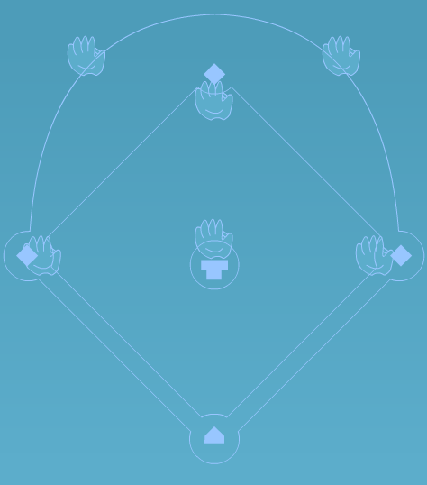
Baseball Diamond
The Baseball Diamond serves as a background for the Baseball bonus wave. It can be used a reference to know where to aim the ball for the most points when batting.

Levels Appendix

This appendix displays a picture and description of every wave in the game.

Waves 1.1 through 1.3

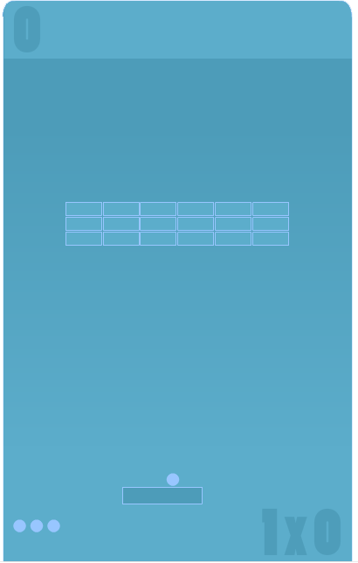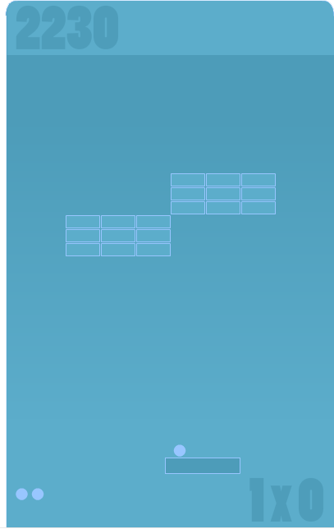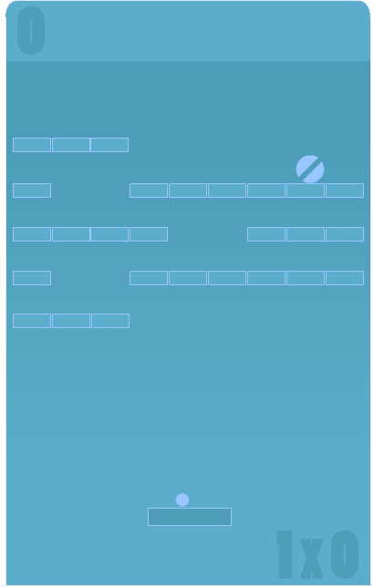
wave 1.1 wave 1.2 wave 1.3
These are the first three waves in the game. The brick pattern in level one is that of a traditional brickbreaker but with fewer bricks to break. This and the second screen get you accustomed to the controls. The second pattern begins to show the player that there will be aesthetically dynamic patterns that mix up the challenge. Wave 1.3 is the first with an enemy-the Twerp. The brick pattern on this wave is different and introduces users to even move brick variety and the concept of enemies.

Waves 2.1 through 2.3

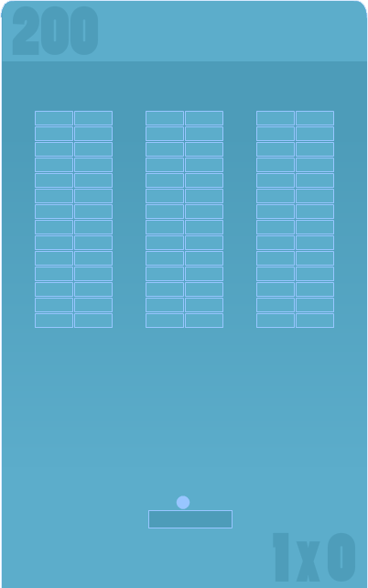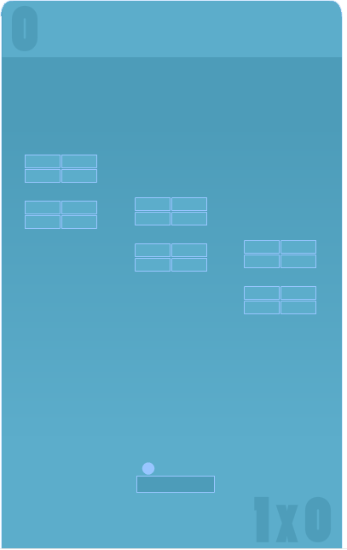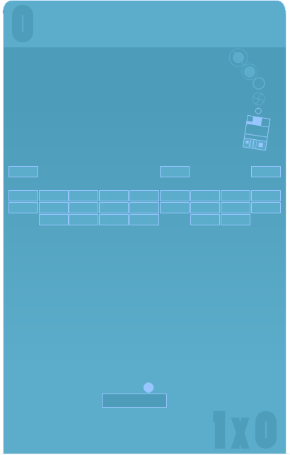
wave 2.1 wave 2.2 wave 2.3
Waves 2.1 through 2.3 appear after the first bonus wave. By now the player is comfortable with the control and can be intro new interesting patterns. 2.1 is the first wave with a lot of bricks. This is a high scoring wave and a fun wave because launching a ball up one on the channels results in mega points with little work. 2.2 has large gaps between brick clusters. This causes the ball to change direction frequently and is more difficult than past waves. The final wave features the Robot and a simple brick wall. The Robot however pushes bricks down toward the player and can regenerate the wall if too many bricks are destroyed but the player. The key to clearing the stage is destroying the Robot so he can no longer regenerate bricks.

Waves 3.1 through 3.3

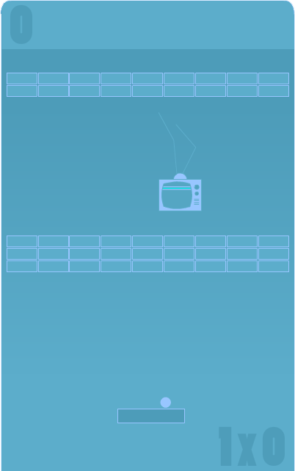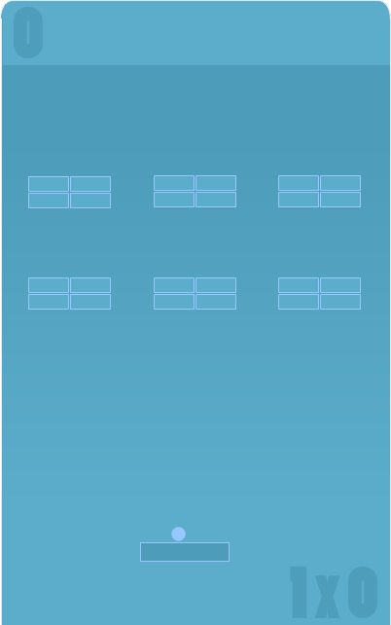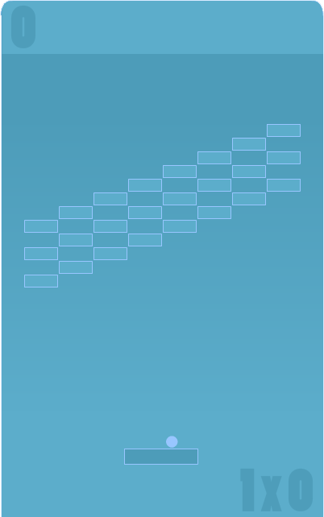
wave 3.1 wave 3.2 wave 3.3
Wave 3.1 introduces yet another enemy and not in the traditional sequence as past stages bricks. There are low brick rows and very high brick rows to clear. The high lows require extra talent in aiming the ball. the Tele fills the screen with light when hit and causes the ball to be invisible for about two seconds. Wave 3.2 serves another gappy level for crazy bounces and 3.3 separates each brick with an empty space requiring the player to work extra hard to clear all the bricks since he will rarely take out two with one shot.

Waves 4.1 through 4.3

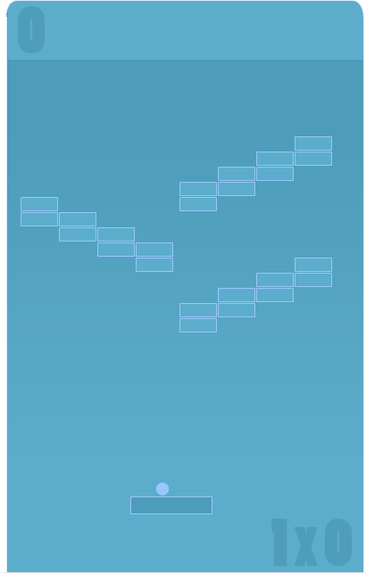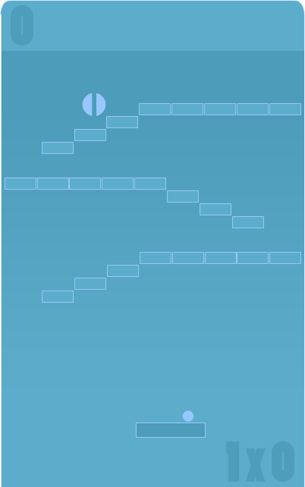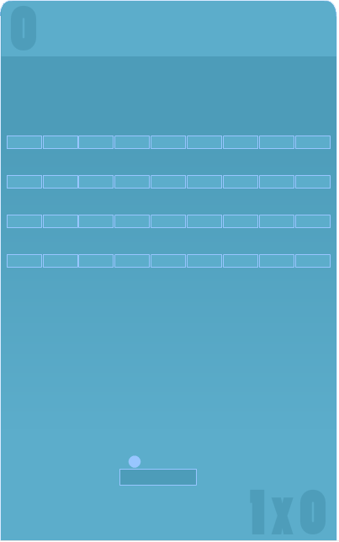
wave 4.1 wave 4.2 wave 4.3
The final waves introduce more visually appealing and rapid directional changes in the ball. Wave 4.2 offers another Twerp with a stair step type pattern. The low bricks on waves 4.1 and 4.2 can be dangerous to take out at high speeds.

Bonus Waves Target and Vong

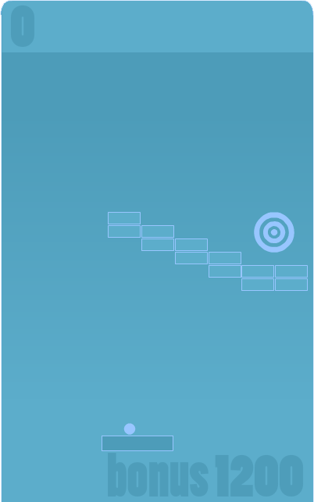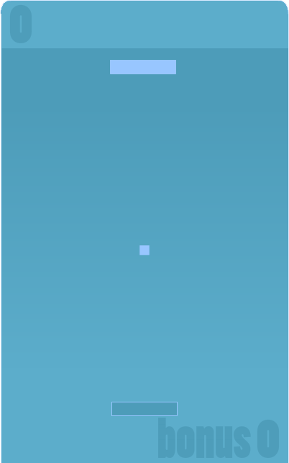
bonus wave target bonus wave vong
Target is the first bonus wave. In Target the player gets one chance to hit eight consecutive targets. As soon as the player launches the ball the paddle disappears and does not reappear until the next target appears. If the ball hits the target points are scored and the next target appears. If the ball falls off the screen no points are awarded and the next target appears. Players do not lose balls for missing targets.

Vong, short for Vertical Pong, pits the player against the Opponent in a game of Pong. The goal is to get as many balls past the Opponent as possible before she scores on you. If one ball gets past you the wave ends. Points are awarded for every goal and the Opponent gets better as you score increases. This bonus wave uses the Classic Ball.

Bonus Waves Juggle and Baseball

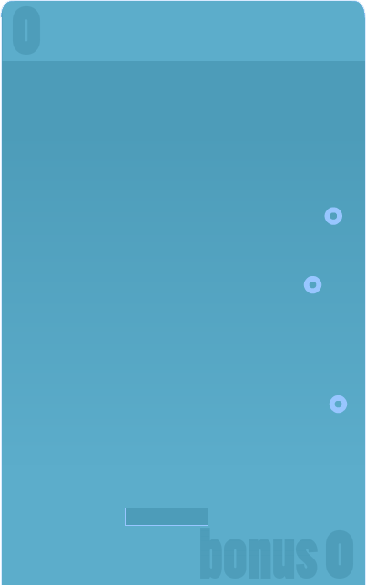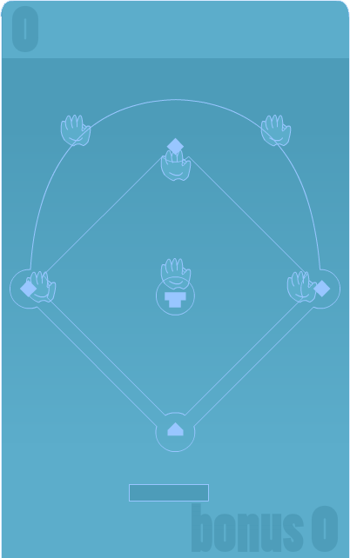
bonus wave juggle bonus wave baseball
In Juggle the goal is to bounce three balls as often as possible before one gets by the paddle. The first ball is replaced by the second to be launched after launching it. The third ball then appears ready for launching after the second ball is in the air. The player is awarded points for each bounce once all three balls have been launched. If one ball falls off the screen at any time the wave is over.

Baseball has the player try to knock a ball past the gloves after being pitched to by the pitcher. The pitcher glove stands on the mound and tosses balls with a limited degree of randomness (they will always pass over the plate but with variety). The glove do not move but getting the Classic Ball past them can be difficult. The location of the ball as it passes off screen determines the event and point value. If the ball goes off the side above the 1st and 3rd basemen but below the 2nd baseman it is a base hit. Going off the screen above that means a homer! Off sides below the 1st and 3rd basemen is a foul and if the player misses the ball and it goes off the bottom of the screen it is a strike. Standard baseball rules apply and you can even load the bases and get a grand slam for a big bonus.

Classic Waves

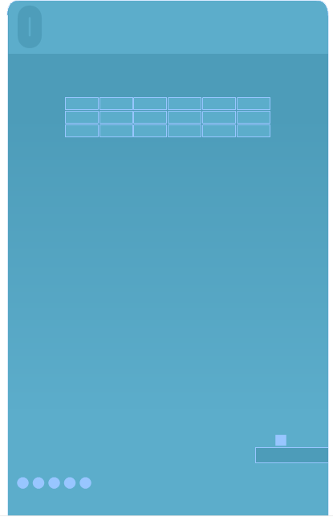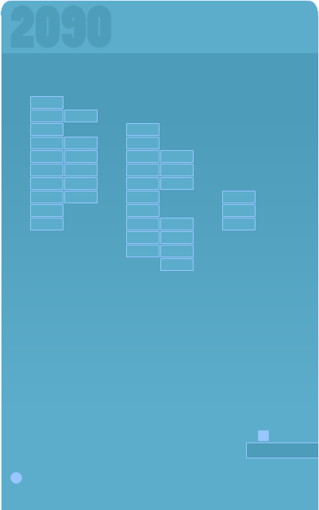
classic wave 1 classic wave 7
Classic waves offer the player more traditional brickbreaker patterns with a larger distance between the paddle and bricks. There are no stages-just wave after wave for a total of 20 waves. There are no bonus waves in this mode and points are awarded for every brick smashed.

User Interface Appendix

The following is a labeled diagram of a PANIC screenshot.

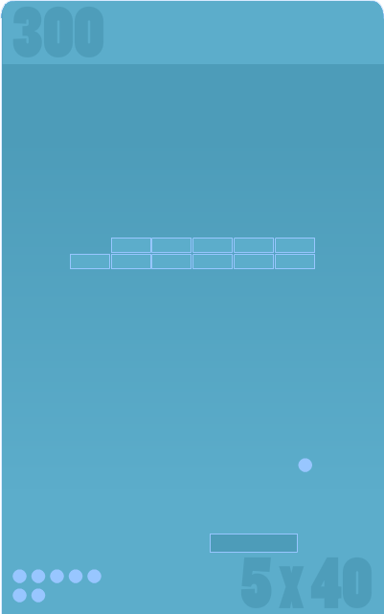

SCORE

BRICK
PATTERN

BALL

PADDLE

BANKBAR
BALL
NUMBER

